Why have u done project in java?
1.Java is easy to learn.
Java was designed to be easy to use and is therefore easy to write, compile, debug, and learn than other programming languages.
2.Java is object-oriented.
This allows you to create modular programs and reusable code.
3.Java is platform-independent.
One of the most significant advantages of Java is its ability to move easily from one computer system to another. The ability to run the same program on many different systems is crucial to World Wide Web software, and Java succeeds at this by being platform-independent at both the source and binary levels.
4.Java is distributed.
Java is designed to make distributed computing easy with the networking capability that is inherently integrated into it. Writing network programs in Java is like sending and receiving data to and from a file.
5.Java is secure.
Java considers security as part of its design. The Java language, compiler, interpreter, and runtime environment were each developed with security in mind.
6.Java is robust.
Robust means reliability. Java puts a lot of emphasis on early checking for possible errors, as Java compilers are able to detect many problems that would first show up during execution time in other languages.
7.Java is multithreaded
Multithreaded is the capability for a program to perform several tasks simultaneously within a program. In Java, multithreaded programming has been smoothly integrated into it, while in other languages, operating system-specific procedures have to be called in order to enable multithreading.
Because of Java's robustness, ease of use, cross-platform capabilities and security features, it has become a language of choice for providing worldwide Internet solutions.
8. Java is both dynamic and extensible. Java code is organized in modular object-oriented units called classes. Classes are stored in separate files and are loaded into the Java interpreter only when needed. This means that an application can decide as it is running what classes it needs and can load them when it needs them. It also means that a program can dynamically extend itself by loading the classes it needs to expand its functionality.
The network-centric design of the Java platform means that a Java application can dynamically extend itself by loading new classes over a network.

What is Object Relational Mapping (ORM)?

In programming, Java developers used to take the JDBC approach for data persistence, which involves writing and executing SQL statements in retrieving/updating data in database. This approach was popular, but probably not a good one because SQL can be difficult to read and write, error prone and hard to debug.

To make programming easier and reduce the chance of making mistakes, many developers prefer not to execute SQL statements directly, but to build an object model that reflects the data structure. In runtime, data will be retrieved from database and filled into the object model. Developers can then work entirely with objects, without writing any SQL statements. The technique to convert data between object model and relational database is known as object-relational mapping (ORM, O/RM and O/R mapping).

Which ORM implementation have u used in ur project? And why?
We have used Hibernate as an ORM implementation in our project. Hibernate has following advantages:

1.Hibernate is database independent. You can work with any database you want like oracle,mysql,db2,sql server ,etc. Using hibernate you won't worry about writing database specific queries and syntax. It's provides HQL (Hibernate Query Language), which is compatible with any database server. You just need to write queries in HQL, at the end hibernate converts HQL to underlying database and executes it.
2. In ORM, you will map a database table with java object called "Entity". So once you map these,you will get advantages of OOP concepts like inheritance, encapsulation,etc.
3. Caching mechanism (1st level & 2nd level cache) provided hibernate means you don't need to hit database for similar queries, you can cache it and use it from buffered memory to improve performance.
4.Supports Lazy loading (also called n+1 problem in Hibernate). Take an example-parent class has n number of child class. So When you want information from only parent,there is no meaning of loading n child classes.This is called lazy loading (Load only thing which you want).

What is Maven?
Maven is a powerful project management tool that is based on POM (project object model). It is used for projects build, dependency and documentation.
What is Maven dependency?
In case of most of the Java web based frameworks such as Struts,Spring,JSF etc, we need to add set of jar files in each project. Maven’s dependency mechanism help to download all the necessary dependency libraries automatically.

What is the advantage of Spring ?
- Lightweight: Spring Framework is lightweight with respect to size and transparency.
- Inversion Of Control (IOC): In Spring Framework, loose coupling is achieved using Inversion of Control. The objects give their own dependencies instead of creating or looking for dependent objects.
- Aspect Oriented Programming (AOP): By separating application business logic from system services, Spring Framework supports Aspect Oriented Programming and enables cohesive development.
- Container: Spring Framework creates and manages the life cycle and configuration of application objects.
- MVC Framework: Spring Framework is a MVC web application framework. This framework is configurable via interfaces and accommodates multiple view technologies.
- Transaction Management: For transaction management, Spring framework provides a generic abstraction layer. It is not tied to J2EE environments and it can be used in container-less environments.
- JDBC Exception Handling: The JDBC abstraction layer of the Spring Framework offers an exception hierarchy, which simplifies the error handling strategy.

What is MVC?

The Model-View-Controller (MVC) is an architectural pattern that separates an application into three main logical components: the model, the view, and the controller. Each of these components are built to handle specific development aspects of an application. MVC is one of the most frequently used industry-standard web development framework to create scalable and extensible projects.

What is Spring MVC?

The Spring Web MVC framework provides Model-View-Controller (MVC) architecture and ready components that can be used to develop flexible and loosely coupled web applications. The MVC pattern results in separating the different aspects of the application (input logic, business logic, and UI logic), while providing a loose coupling between these elements.
- The Model encapsulates the application data and in general they will consist of POJO.
- The View is responsible for rendering the model data and in general it generates HTML output that the client's browser can interpret.
- The Controller is responsible for processing user requests and building an appropriate model and passes it to the view for rendering.

How does SpringMVC work?

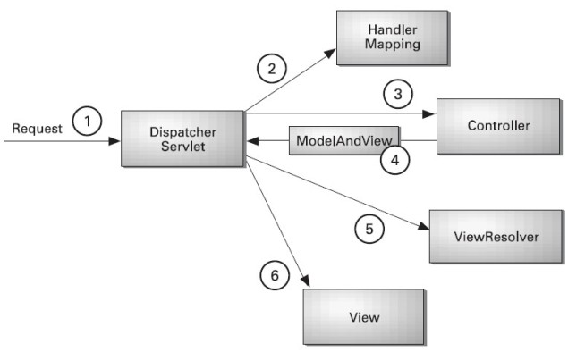
- After receiving an HTTP request, DispatcherServlet consults the HandlerMapping to call the appropriate Controller.
- The Controller takes the request and calls the appropriate service methods based on used GET or POST method. The service method will set model data based on defined business logic and returns view name to the DispatcherServlet.
- The DispatcherServlet will take help from ViewResolver to pickup the defined view for the request.
- Once view is finalized, The DispatcherServlet passes the model data to the view which is finally rendered on the browser.

What is the advantage of Spring MVC?
Spring is a powerful Java application framework, used in a wide range of Java applications. It provides enterprise services to Plain Old Java Objects (POJOs). Spring uses dependency injection to achieve simplification and increase testability.
1. Spring provides a very clean division between controllers, JavaBean models, and views.
2. Spring’s MVC is very flexible. Unlike Struts, which forces your Action and Form objects into concrete inheritance.
3. Spring Controllers are configured via IoC like any other objects. This makes them easy to test, and beautifully integrated with other objects managed by Spring.
4. Spring, like WebWork, provides interceptors as well as controllers, making it easy to factor out behavior common to the handling of many requests.
5. Spring offers better integration with view technologies other than JSP (Velocity / XSLT / FreeMarker / XL etc.)5. Spring Controllers are configured via IoC like any other objects. This makes them easy to test, and beautifully integrated with other objects managed by Spring.

What is DAO?
DAO is a design pattern.
The Data Access Object manages the connection with the data source to obtain and store data.It abstracts the underlying data access implementation for the Business Object to enable transparent access to the data source. A data source could be any database such as an RDBMS, XML repository or flat file system etc.
Its in all referred as DAO Pattern, It consist of following:
- Data Access Object Interface - This interface defines the standard operations to be performed on a model object(s).
- Data Access Object concrete class -This class implements above interface. This class is responsible to get data from a datasource which can be database / xml or any other storage mechanism.
- Model Object or Value Object - This object is simple POJO containing get/set methods to store data retrieved using DAO class.

